HM200 Checkpoints

Yellow blobs are the check points

Arrows are the direction in which the runners will be running/walking/crawling

# RACE START Queen Victoria Docks V/Hall  110 287  Postcode – HU9 ITL  Start -0800

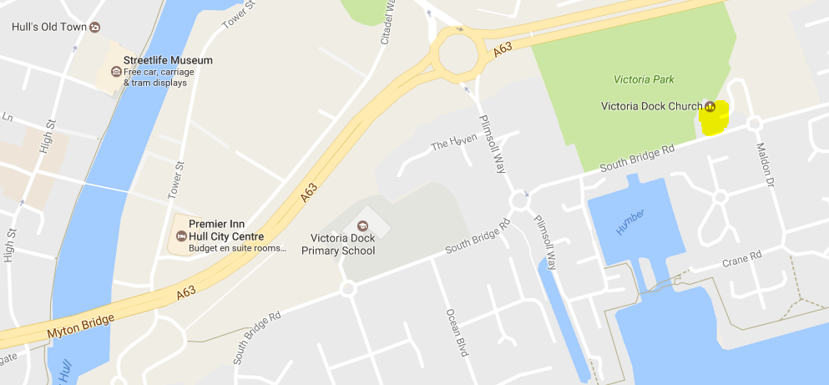

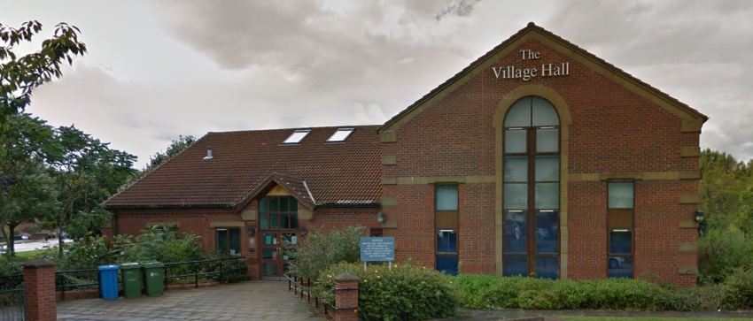

# Wolds Way Start 028 253 HU13 OHE  Humber Bridge Carpark, Cliff Rd

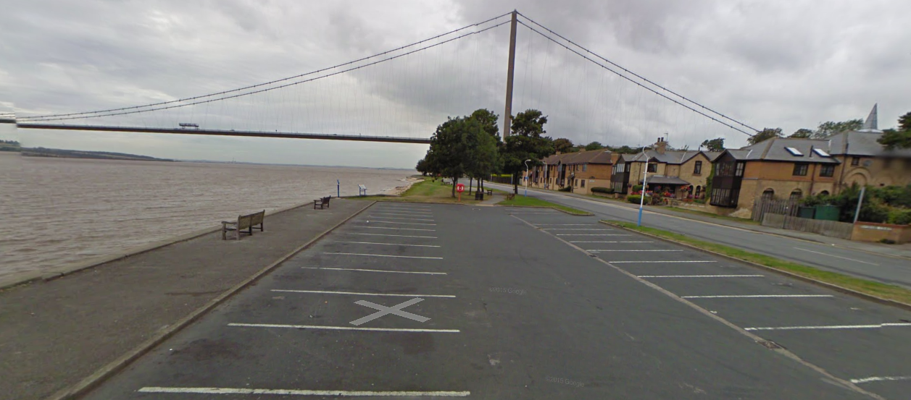

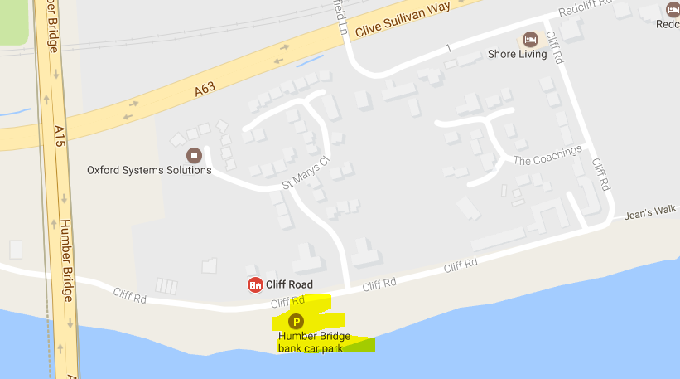

# Brantingham (nr Church) 943 301  HU15 1QN (17 miles) COMPULSORY

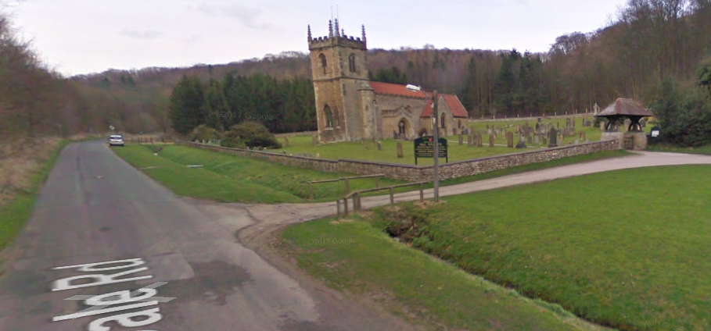

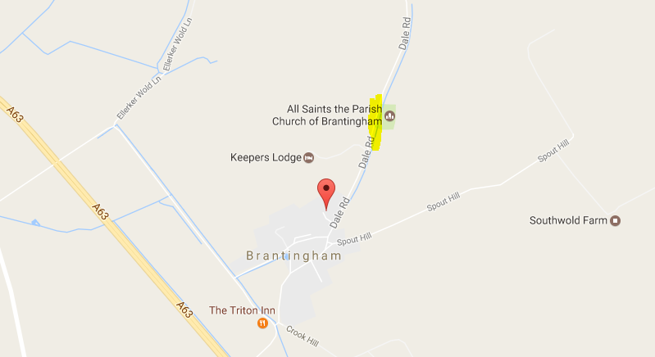

# Arras Wold (nr 1079) 925 412  Postcode  – YO43 4RL   10 miles (27)

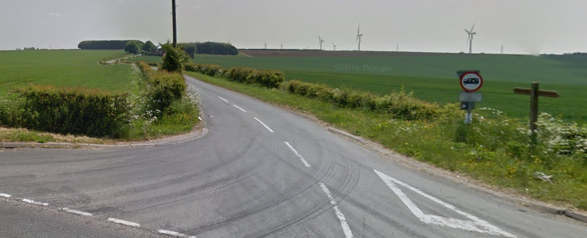

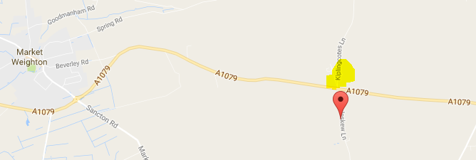

# MARKET WEIGHTON, Hall Road  877 4192  YO43 3BA  (30.5 miles)

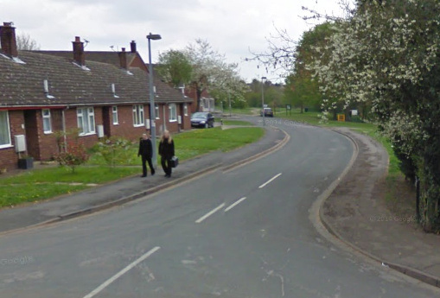

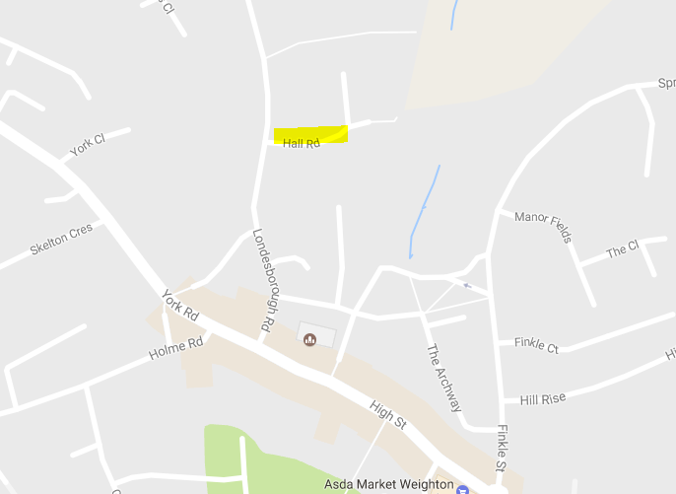

# Millington V/Hall  831 519  YO42 1TX  (40 miles) COMPULSORY

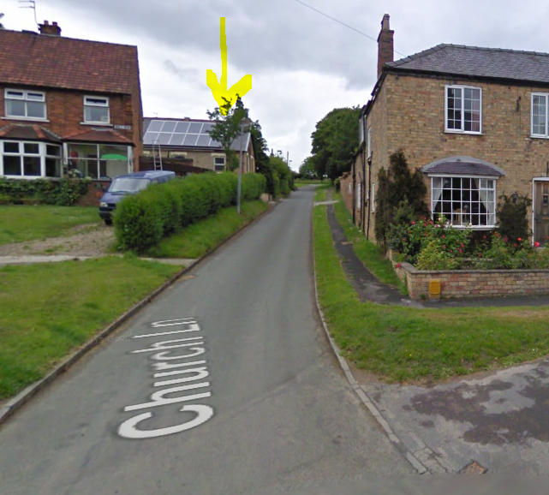

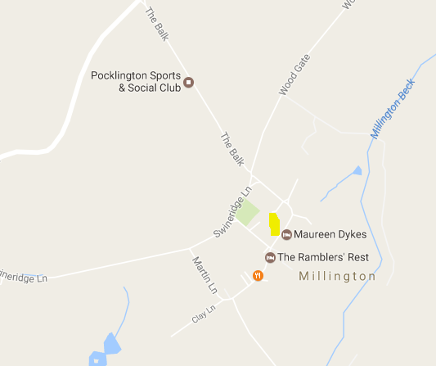

# FRIDAYTHORPE Back Street  873 592  YO25 9RW (48 miles)

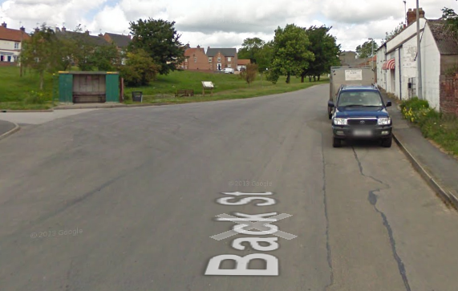

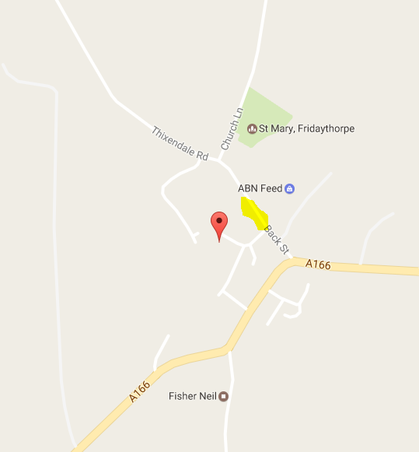

# Wharram Percy (Carpark) 866 644  (57 miles) COMPULSORY

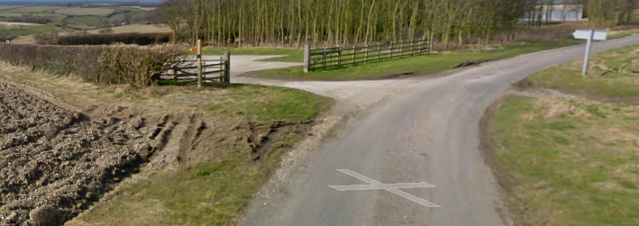

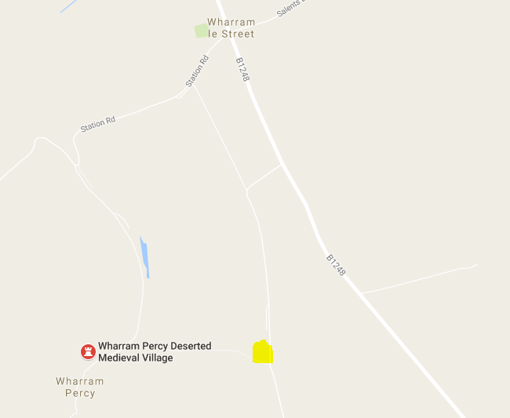

# Wintringham 878 734  Postcode -YO17 8HP  8 miles (65) Cut Off 0100

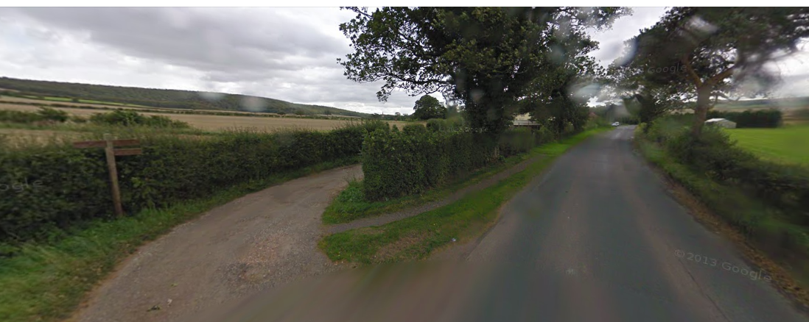

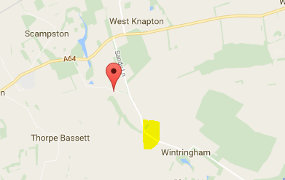

# Checkpoint 7   Flixton Wold (road) 047 775  14 miles (79)

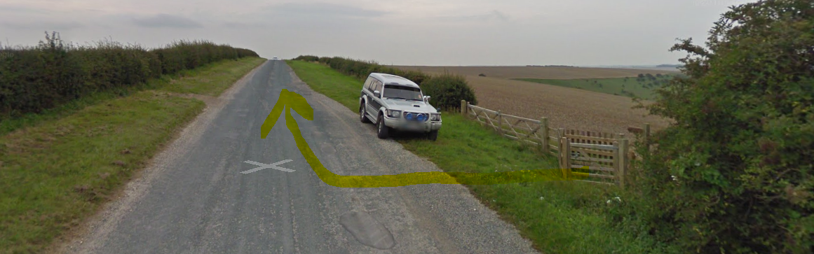

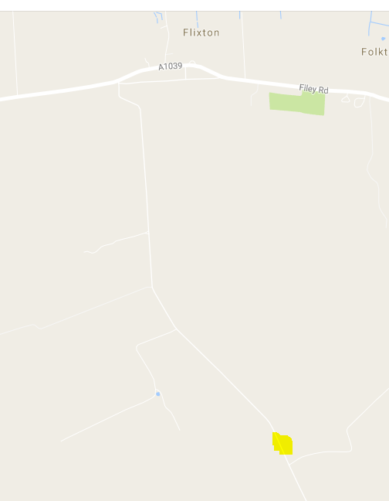

# Filey Brigg (110 Start) 124 816  YO14 9ET  (88 miles) COMPULSORY

Start of the Cleveland way

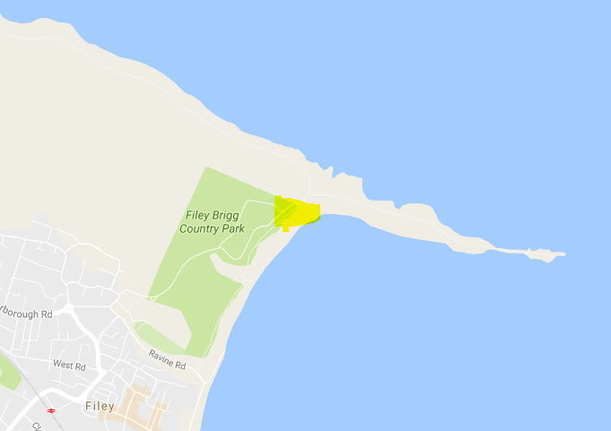

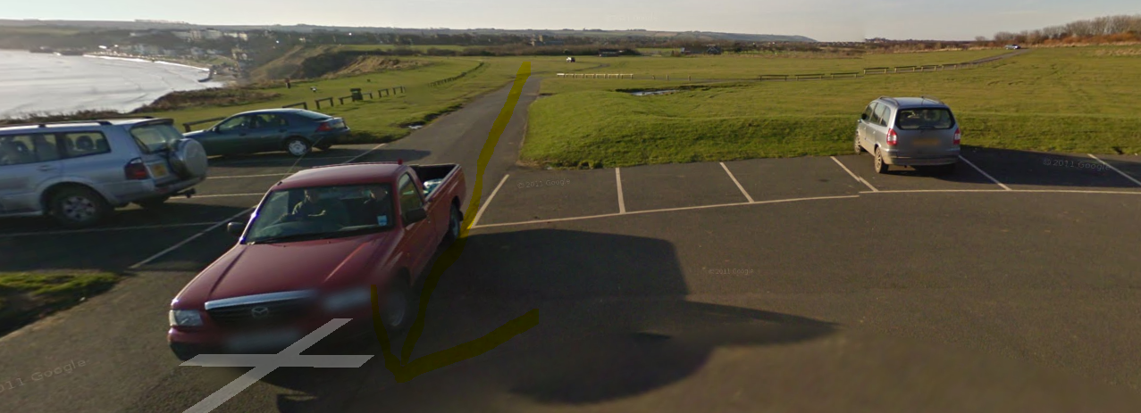

# SCARBOROUGH (Holbeck Carpark) 049 867 YO11 2XD

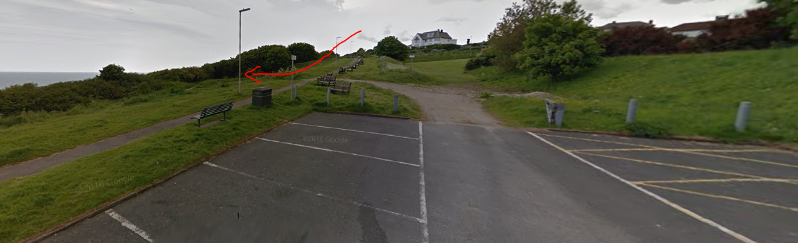

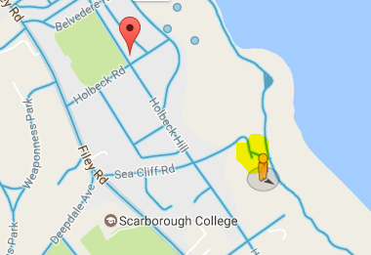

# RAVENSCAR Village Hall  981 010 YO13 OLZ COMPULSORY

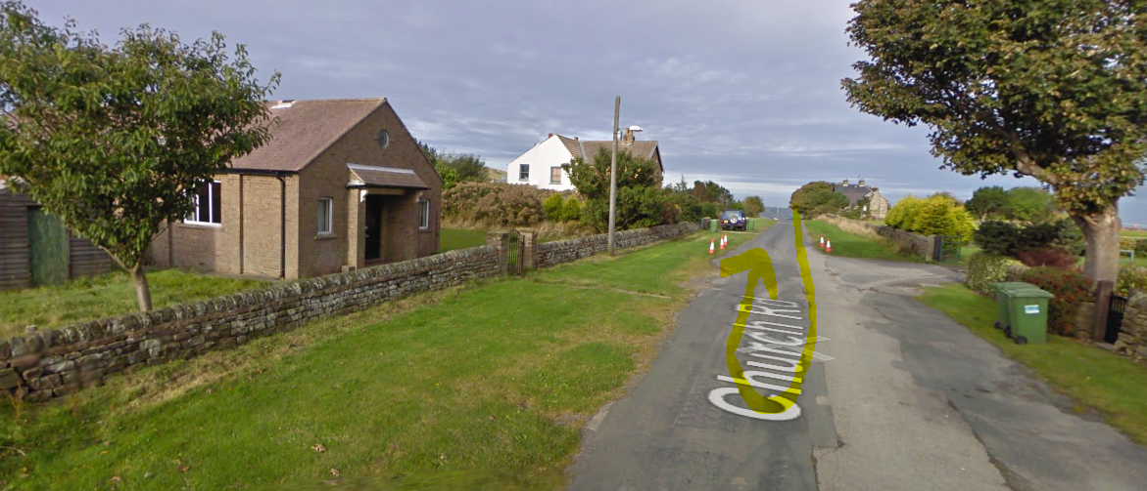

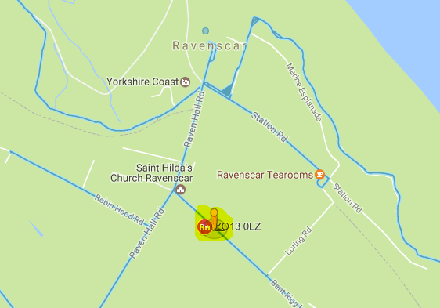

# Robin Hoods Bay (Not a checkpoint)

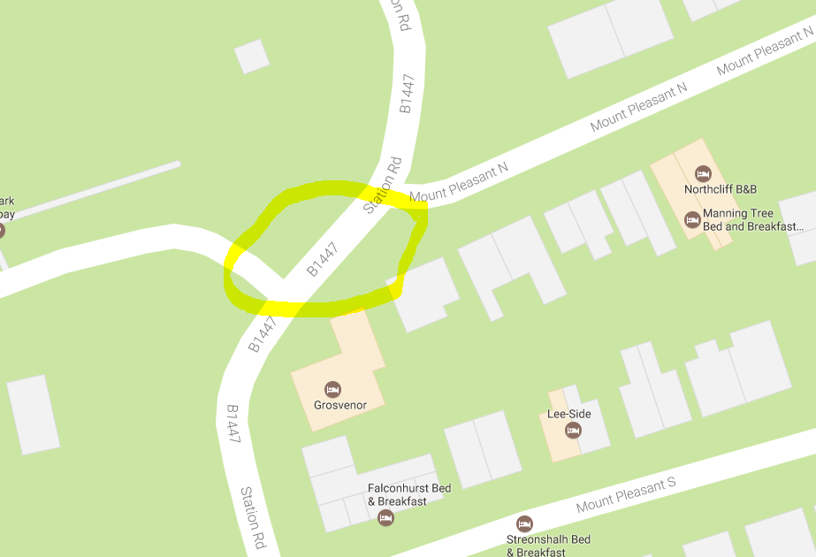

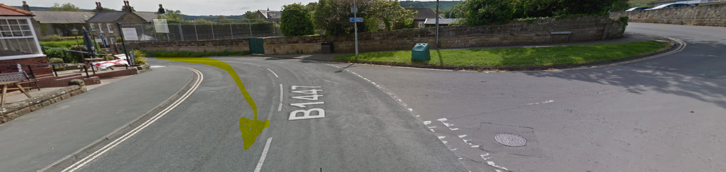

SANDSEND (Seafront Carpark) 860 129  YO21 3TG

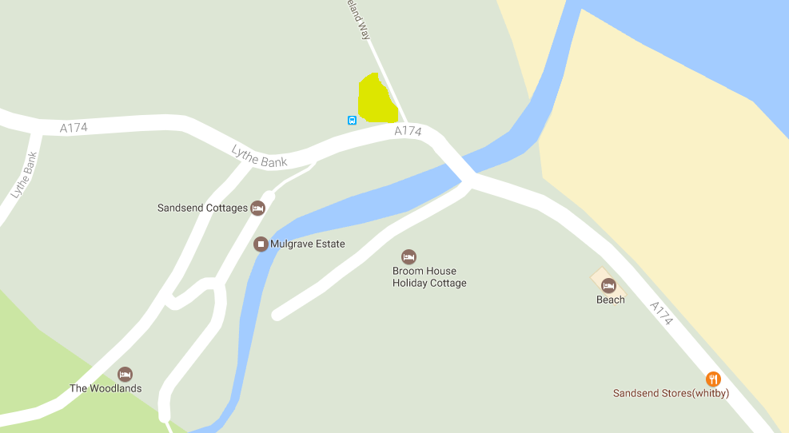

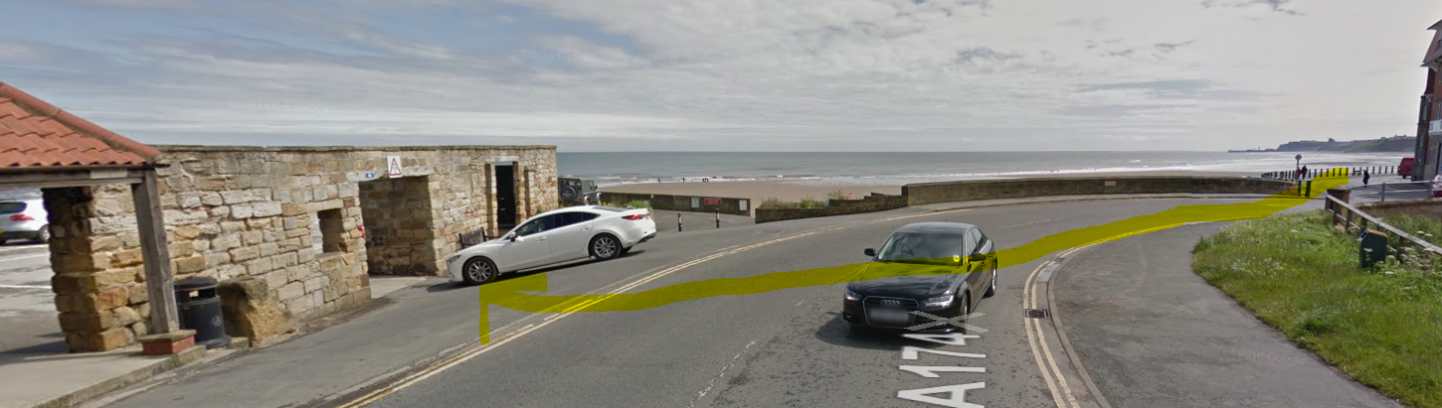

RUNSWICK BAY (Upper carpark) 807 161 TS13 5JF COMPULSORY

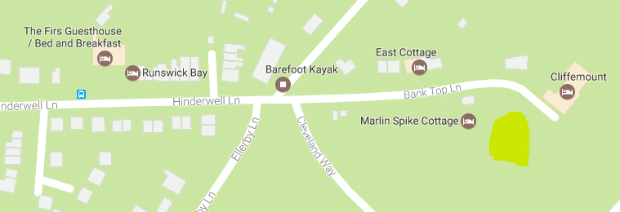

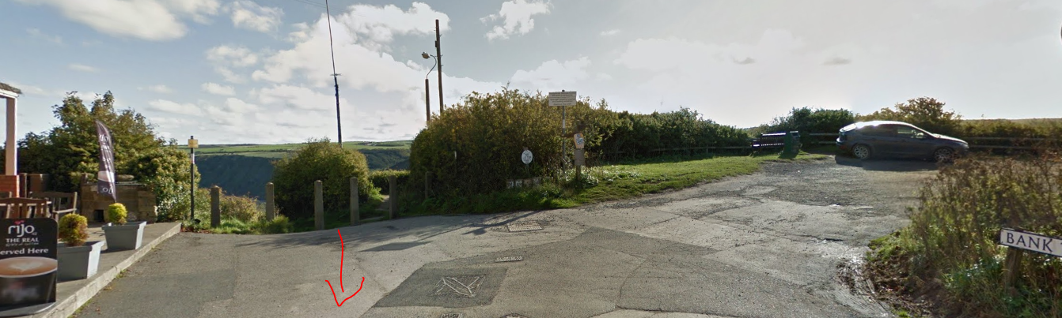

SALTBURN  (Seafront Carpark) 667 216  TS12 IHQ  COMPULSORY

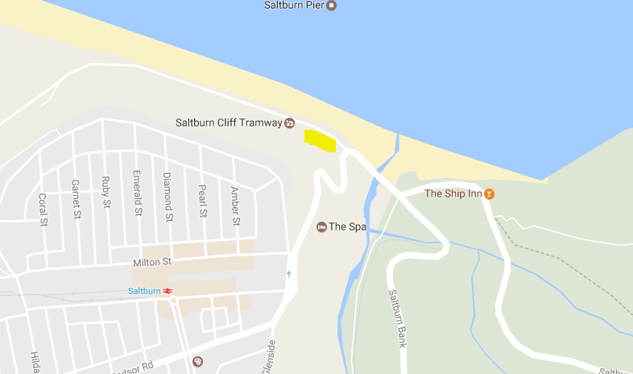

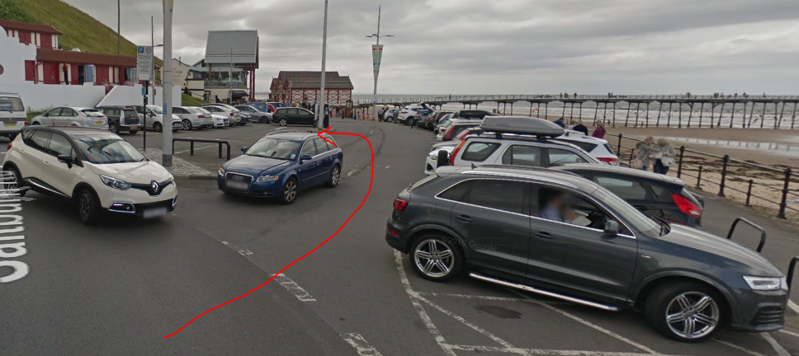

FOX AND HOUNDS PUB, Slapewath 643 158

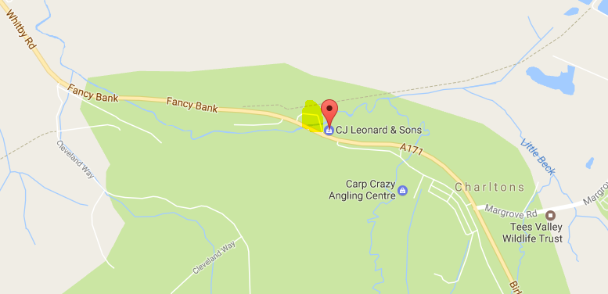

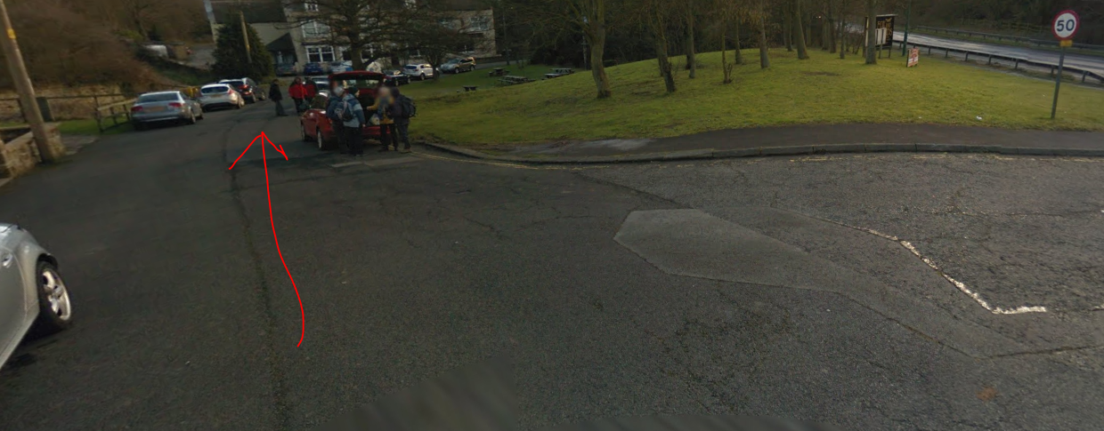

DIKES LANE CARPARK   592 110 TS9 6HJ (Between Captain Cooks & Gt Ayton Moor)

There is a checkpoint on Roseberry Topping but support teams don’t normally go there as it’s just before Dikes Lane Carpark

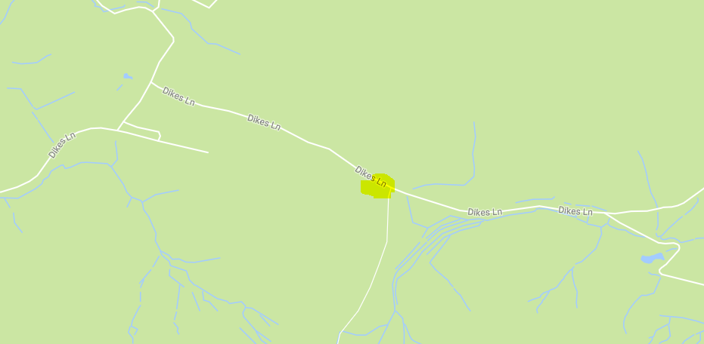

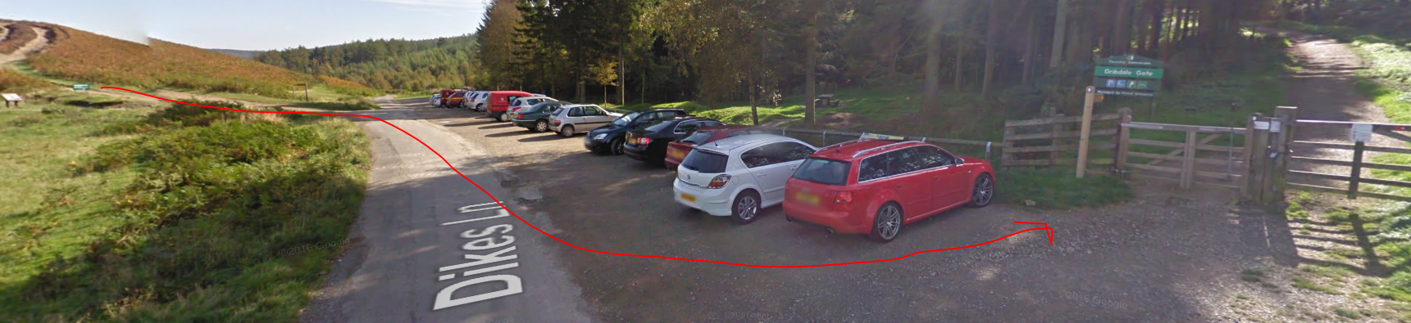

**No support allowed in Kildale**

CLAY BANK (B1257) 571 034

TS9 7HY  COMPULSORY

Take care on the road!

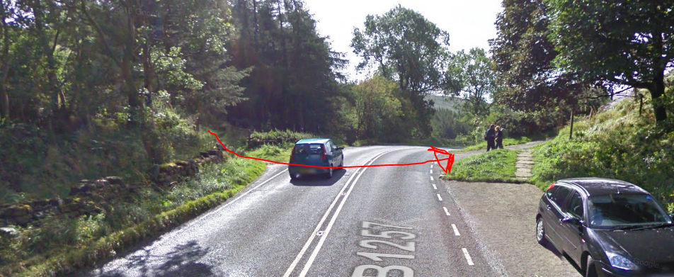

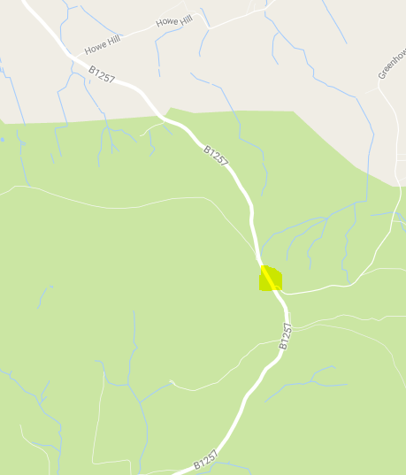

**No support allowed in Osmotherly Village**

SQUARE CORNER  (Osmotherley) 518 812 DL6 3QB  COMPULSORY

**Note – this is not in the village but on the hill to the East**

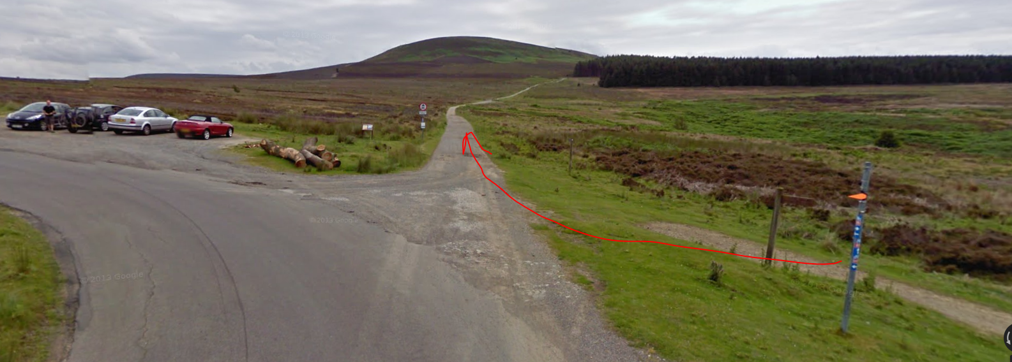

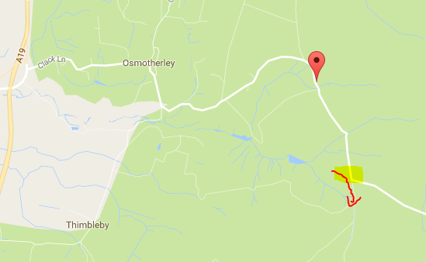

Sutton Bank Car Park (Not a check point)

Take care – busy road

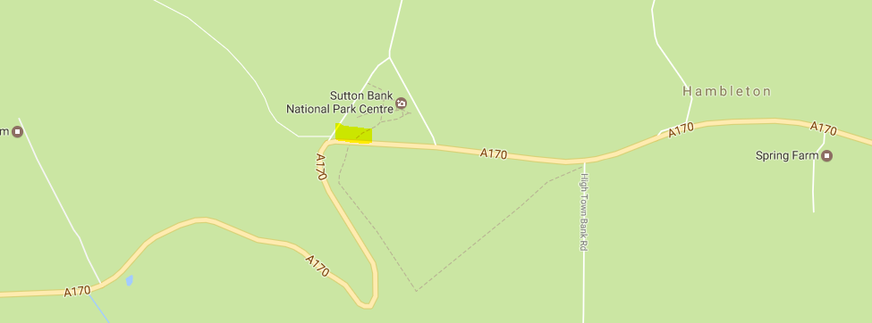

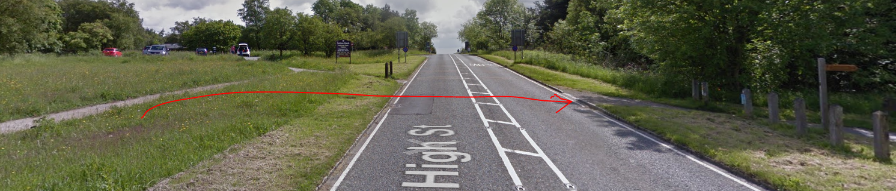

WHITE HORSE (Carpark) 518 812  YO61 4AN  COMPULSORY

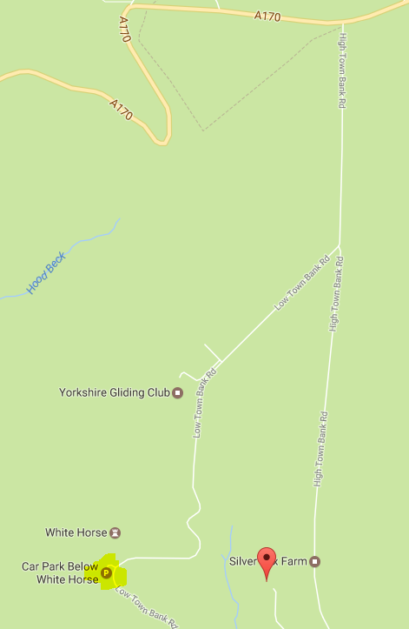

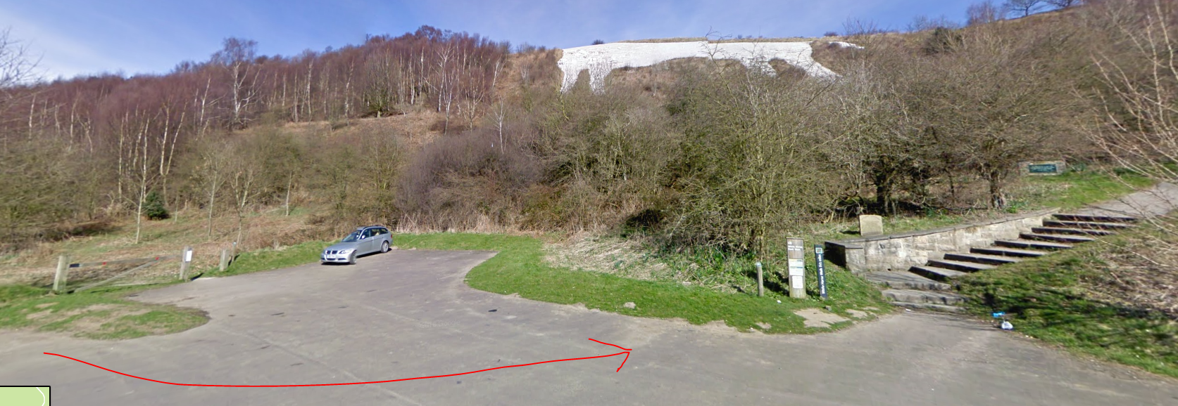

RACE FINISH Helmsley Sports Club 610 843  Postcode – YO62 5BH 10 miles (200)

